POST-DOCTORAL FELLOW

JOB DESCRIPTION
Job Title : 3D Thermo-Mechanically Coupled Geodynamic Modeling of Collision

Job Summary:
The position involves developing models of collision initiation using the open source code pTatin3d, based on literature data and newly acquired data from the ANR Collisea project.

Context
The position is part of the ANR Collisea, a collaborative project that brings together geologists and geophysicists from several French partners (Univ. Toulouse 3 – Paul Sabatier, Sorbonne Univ., Cergy Univ., ENS-Paris) and international partners (Nat. Central Univ. and Nat. Chung Cheng Univ. in Taiwan and the NIGS in the Philippines). The project aims to determine how the resistance, buoyancy, and architecture of continental margins control collision initiation. Collision initiation is defined as the beginning of accretion of the marginal part of continents. Compared to subduction initiation or mature collision stages, collision initiation is not integrated into plate tectonic models used to predict earthquakes and orogenic growth, nor in current estimates of crustal recycling on Earth. However, the tectonic and magmatic events that pre-structured the continental lithosphere of passive margins before convergence must significantly control the thermal, mechanical, structural, and topographic evolution during collision initiation. These parameters can be better understood by improving geophysical imaging of the subduction-collision transition, detailed description of the passive margin before accretion, combined with 3D thermomechanical modeling capable of integrating plate motion complexities. Only a limited number of active convergent plate boundaries retain markers of this transitional phenomenon. COLLISEA focuses on the only active arc-continent collision where pre-accretion structures are available. COLLISEA will focus on 3 sites (Taiwan, Palawan, and Mindoro Islands) that form a coherent set, characterizing different stages of collision initiation between the margins of the South China Sea (SCS) and the Philippine Mobile Belt (PMB) island arcs (see Fig).
To establish a precise picture of the kinematics of the plate boundary, and unveil the possible control by plate kinematics versus the SCS margin architecture, the project proposes to determine timing and duration of cooling and exhumation using low-temperature thermochronological analyses and compare them to the results of 3D thermo-mechanical models of collision initiation which account for plate reconstructions hypotheses as well as knowledge/hypothesis on the passive margin structure.

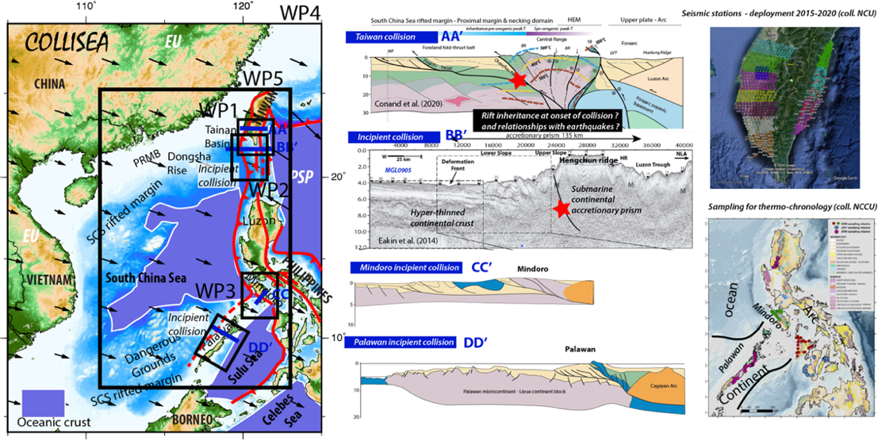 | Figure 2 : Targeted domains of SCS in COLLISEA, work packages and some relevant data available for the project including seismic profile, seismic stations deployment and thermochronological data.

Profile and mission
The selected candidate will be responsible for carrying out numerical simulations of work package 5 (see Fig). The objective is to develop 3D thermo-mechanical numerical simulations of the inversion of the passive margin of the SCS in an oblique convergence context, using the open-source code pTatin3D. The 3D modeling approach will incorporate a recently developed coupling between GPlates and pTatin3d in order to test different reconstruction hypotheses developed with the timing of exhumation and cooling of rocks and the structures developed during collision imaged by geophysics.
The candidate must have experience in thermo-mechanical numerical modeling. They will be responsible for implementing the numerical tools at their disposal and developing them as much as possible and as needed for the project, as well as publishing their results in articles. We also expect the candidate to work with the rest of the project team.

Research domain : Geodynamics

Work Environnement
Type of contract : short term : 2 years
Status : postdoctoral fellow
Salary : according to experience ranging from index 537 à 740 (1 = 4,85003 euros brut)
Employer : Sorbonne University
The University :
Sorbonne University is a dynamic and vibrant research university, born from the merging of Paris-Sorbonne and UPMC universities. With 54,000 students, including 4,700 doctoral candidates and 10,200 international students, and a team of 6,300 passionate teachers, researchers, and professors, as well as 4,900 dedicated staff in library, administrative, technical, social, and health services, it's a melting pot of ideas and innovation. With a budget of €670 million, Sorbonne University is dedicated to providing an outstanding education and a supportive environment. Its Faculty of Science and Engineering is situated in the heart of Paris on the Pierre and Marie Curie campus, accessible via metro lines 7 and 10, making it a highly sought-after destination for scholars and students alike.
The Lab :
ISTeP, the Institute of Earth Sciences at Sorbonne University, is a hub of cutting-edge research in a wide range of fields, including the dynamics of sedimentary basins, mountain ranges, and continental margins. Their research themes also extend to biomineralization, natural hazards, and planetary dynamics, as well as the physico-chemical properties of natural materials like minerals and magmas. Their research approach spans from fieldwork to thermomechanical numerical modeling, supported by state-of-the-art analytical tools like spectrometers, microprobes, and GIS software. With numerous national and international collaborations, ISTeP is a leading institution that provides unparalleled opportunities for students to train in the exciting field of Earth Sciences.

Adresse : Campus Pierre et Marie Curie, Tour 46-0, 2ème Etage, 4 place Jussieu, 75005 PARIS
MODALITES DE CANDIDATURE
Start date : flexible between 1/09/2023 to 1/12/2023
Applications close : 15/05/2023
To apply send your CV and motivation letter to :
Laetitia Le Pourhiet laetitia.le_pourhiet@sorbonne-universite.fr

